集美大学计算机工程学院实验报告

课程名称：编译原理 | 指导教师：汪志华 | 实验成绩：
实验项目编号： 002 | 实验项目名称：递归下降分析器的设计
班级：计算2114 | 姓名：庄佳强 | 学号：202121331104
上机实践日期：2023.11.2 | 上机实践时间：4 学时

- 实验目的
根据文法编制递归下降分析程序，以便对输入的符号串进行语法分析。通过编写递归下降分析程序掌握递归下降分析法的基本原理以及递归下降分析程序的构造方法。

二、实验内容
对下列指定的文法编写递归下降分析程序，要求对输入的任意符号串进行语法分析。该文法描述了C语言的变量定义语句、赋值语句。
(1) program —> declaration-list statements
(2) declaration-list —>var-declaration declaration-list |ε
(3) var-declaration —> type-specifier id-list ;
(4) type-specifier —> int | double
(5) id-list —> ID list-tail
(6) list-tail —>, ID list-tail |ε
(7) statements —> statement ; statements |ε
(8) statement —> assign_statement
(9) assign_statement —> ID = expr
(10) expr—> term expr1
(11) expr1 —> +term expr1 | -term expr1 |ε
(12) term —> factor term1
(13) term1 —> *factor term1 | /factor term1 |ε
(14) factor —> (expr) | ID | NUM
注：文法中ID表示标识符（此处标识符的定义与实验二中标识符的定义相同），NUM表示数字
三、实验要求
1、 输入/输出格式
输入一个测试的源文件，判断该文件是否是满足上述语法规则的程序。
例如：
int a,b,c;
a = 20;
b = a+10;
c= a*b-b/a;
则为正确的程序
2、上述要求仅为基本要求，可以在此基础上扩充，例如数字可以允许是浮点数，增加错误处理，输出错误信息等。进一步可以指出出错的位置。
3、也可以在文法规则（8）增加更多的语句类型，如if, while语句等，语法规则可参考资料“编译器设计方案.pdf”。
4、编程语言不限。

- 实验设计方案（模块的设计、模块关系简图、流程图、全局变量、函数接口等）

模块的设计：
- 读入测试代码后，实现要对其做一次分词，把标识符，’:’ , ’；’,’/’ ，数字，保留字分割出到一个vector容器中，所有设计了一个word_divider函数对代码进行分词模块。
- 要从文件中读取代码，写了一个读取代码的模块。
- 之后要进行梯度下降分析，写一个class 用来这个工作， 从program()开始压栈，一层层分析。
流程图：
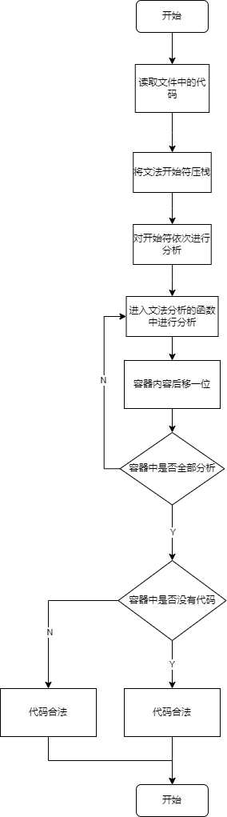

- 测试方案及测试结果

程序会自动读取test.txt中的内容，
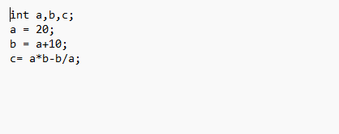
然后进行计算得出分析的过程和分析得出的结果。

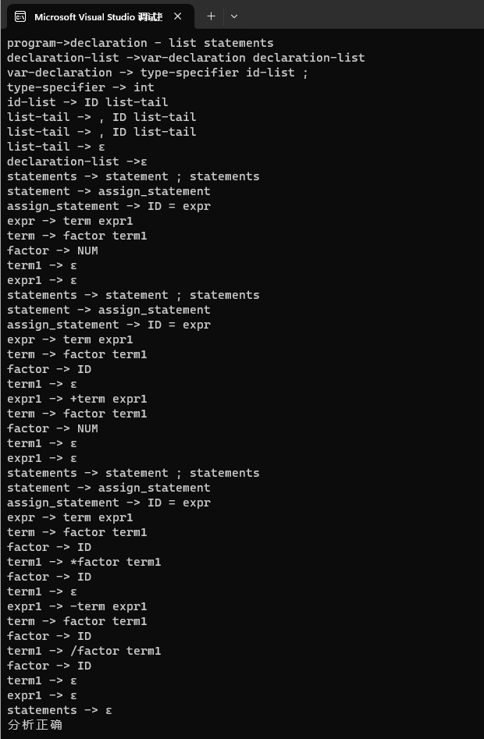

六、实验小结
1. 实验中遇到的问题及解决过程
问题1：栈的使用不太熟练。
分析：代码不熟悉。
解决方案：复习一下。

2. 实验体会和收获。

对递归下降分析器的构造有了更深的理解，也更熟练地掌握了栈的实现。

附录：主要方法的源代码

//用于分词的

word_divider.h
#pragma once

#include<iostream>
#include<vector>
#include<string>
using namespace std;

vector<string> Reserved = { "restrict", "struct", "union", "enum", "typedef", "sizeof", "auto", "static", "register", "extern", "const",
"volatitle", "break", "goto", "else", "switch", "case", "default", "continue", "do", "double", "float","int" };// 保留字表

void Word_divier(const string str,vector<string> &result)
{

//init();

//vector <string> result;//记录结果

//开始处理读入的代码
int length_str = str.length();
string word;
for (int i = 0; i < length_str; i++)
{
//当遇到空格或换行时，跳过继续执行
if (str[i] == ' ' || str[i] == '\n') continue;
//识别常数
else if (isdigit(str[i]))
{

//以字符串形式表示这个常数
while (isdigit(str[i]))
{
word ="num";
i++;
}
i--;
}
//识别基本字或标识符
else if (isalpha(str[i]))
{

//以字符串形式表示这个基本字或者标识符
while (isdigit(str[i]) || isalpha(str[i]))
{
word += str[i];
i++;
}
i--;
vector<string>::iterator it = find(Reserved.begin(), Reserved.end(), word);
if (it == Reserved.end()) {
word = "id";
}

}
//识别运算符
else
{

switch (str[i])
{

case '+':
{

word = "+";
break;
}
case '-':
{

word = "-";
break;
}
case '*':
{

word = "*";
break;
}
case '/': {

word = "/";
break;
}
case '=': {

word = "=";
break;
}
case '<': {
i++;
if (str[i] == '>')
{

word = "<>";

}
else if (str[i] == '=')
{

word = "<=";

}
else if (str[i] == '<')
{

word = "<<";
}
else
{
i--;

word = "<";
}
break;
}
case '>': {
i++;
if (str[i] == '=')
{

word = ">=";
}
else if (str[i] == '>') {

word = ">>";
}
else

{
i--;

word = ">";
}
break;
}
case ':':
{

word = ":";
break;
}
//分割界符
case '(':
{

word = "(";
break;
}
case ')':
{

word = ")";
break;
}
case ',':
{

word = ",";
break;
}
case ';':
{

word = ";";
break;
}
case '{':
{

word = "{";
break;
}
case '}':
{

word = "}";
break;
}
case '[':
{

word = "[";
break;
}
case ']':
{

word = "]";
break;
}

//错误处理
default:

break;
}

}
if (word != "") {

result.push_back(word);

word = "";
}

}

}

//分析的主程序
Gradient_descent_analyzer.cpp

#include<iostream>
#include<vector>
#include<stack>
#include<map>
#include<string>
#include<list>
#include <fstream>
#include"Word_divider.h"

using namespace std;

class analyzer {

public:

analyzer() {
word_stack.push("#");
lookhead = 0;

}
~analyzer() {

}

void program() {//program -> declaration-list statements
word_stack.push("statements");//语句
word_stack.push("declaration-list");//声明
cout << "program->declaration - list statements" << endl;
declaration_list();
statements();

}

private:
void declaration_list() {//declaration-list ->var-declaration declaration-list |ε
if (lookhead < Processing_complete.size() && (Processing_complete.at(lookhead).compare("int")==0 || Processing_complete.at(lookhead).compare("double") == 0) ){
word_stack.pop();
word_stack.push("declaration-list");
word_stack.push("var-declaration");
cout << "declaration-list ->var-declaration declaration-list" << endl;
var_declaration();
declaration_list();
}
else {
word_stack.pop();
cout << "declaration-list ->ε" << endl;
}
}
void var_declaration() {//var-declaration -> type-specifier id-list ; 声明
word_stack.pop();
word_stack.push(";");
word_stack.push("id-list");
word_stack.push("type-specifier");
cout << "var-declaration -> type-specifier id-list ;" << endl;
type_specifier();
id_list();
if (Processing_complete.at(lookhead).compare(";")==0) {
word_stack.pop();
lookhead++;
}
}
void type_specifier() {//type-specifier -> int | double 类型
if (Processing_complete.at(lookhead).compare("int") == 0) {
lookhead++;
cout << "type-specifier -> int" << endl;
word_stack.pop();
}
else if (Processing_complete.at(lookhead).compare("double") == 0) {
lookhead++;
cout << "type-specifier -> double" << endl;
word_stack.pop();
}
}
void id_list() {//id-list -> ID list-tail
word_stack.pop();
word_stack.push("list-list");
word_stack.push("ID");
cout << "id-list -> ID list-tail" << endl;
if (Processing_complete.at(lookhead).compare("id")==0) {
word_stack.pop();
lookhead++;
}
list_tail();
}

void list_tail() {//list-tail -> , ID list-tail |ε
if (Processing_complete.at(lookhead).compare(",") == 0) {
word_stack.pop();
word_stack.push("list-tail");
word_stack.push("ID");
lookhead++;
if (Processing_complete.at(lookhead).compare("id")==0) {
word_stack.pop();
lookhead++;
}
cout << "list-tail -> , ID list-tail" << endl;
list_tail();
}
else {
word_stack.pop();
cout<<"list-tail -> ε"<<endl;
}
}

void statements() {//statements -> statement ; statements |ε
bool flag = false;
for (int n = lookhead ; n < Processing_complete.size(); n++) {
if (Processing_complete.at(n).compare(";")==0) {
flag = true;
break;
}
}
if (flag == true) {
word_stack.pop();
word_stack.push("statements");
word_stack.push(";");
word_stack.push("statement");
cout<<"statements -> statement ; statements"<<endl;
statement();
if (Processing_complete.at(lookhead).compare(";")==0) {
word_stack.pop();
lookhead++;
}
statements();
}
else {
word_stack.pop();
cout<<"statements -> ε"<<endl;
}

}

void statement() {//statement -> assign_statement
word_stack.pop();
word_stack.push("assign_statement");
cout << "statement -> assign_statement"<<endl;
assign_statement();
}

void assign_statement() {//assign_statement -> ID = expr 赋值语句
word_stack.pop();
word_stack.push("expr");
word_stack.push("=");
word_stack.push("ID");
cout<<"assign_statement -> ID = expr"<<endl;
if (Processing_complete.at(lookhead).compare("id")==0) {
word_stack.pop();
lookhead++;
if (Processing_complete.at(lookhead).compare("=")==0) {
word_stack.pop();
lookhead++;
}
}
expr();
}

void expr() {//expr -> term expr1 表达式
word_stack.pop();
word_stack.push("expr1");
word_stack.push("term");
cout<<"expr -> term expr1"<<endl;
term();
expr1();
}

void expr1() {//expr1 -> +term expr1 | -term expr1 |ε
word_stack.pop();
if (Processing_complete.at(lookhead).compare("+")==0) {
word_stack.push("expr1");
word_stack.push("term");
cout<<"expr1 -> +term expr1"<<endl;
lookhead++;
term();
expr1();
}
else if (Processing_complete.at(lookhead).compare("-")==0) {
word_stack.push("expr1");
word_stack.push("term");
cout<<"expr1 -> -term expr1"<<endl;
lookhead++;
term();
expr1();
}
else {

cout<<"expr1 -> ε"<<endl;
}

}

void term() {// term -> factor term1 数项
word_stack.pop();
word_stack.push("term1");
word_stack.push("factor");
cout << "term -> factor term1"<<endl;
factor();
term1();
}

void term1() {//term1 -> *factor term1 | /factor term1 |ε
if (Processing_complete.at(lookhead).compare("*")==0) {
word_stack.pop();
word_stack.push("term1");
word_stack.push("factor");
cout<<"term1 -> *factor term1"<<endl;
lookhead++;
factor();
term1();
}
else if (Processing_complete.at(lookhead).compare("/")==0) {
word_stack.pop();
word_stack.push("term1");
word_stack.push("factor");
cout<<"term1 -> /factor term1"<<endl;
lookhead++;
factor();
term1();
}
else {
word_stack.pop();
cout<<"term1 -> ε"<<endl;
}
}

void factor() {//factor -> (expr) | ID | NUM 参数
if (Processing_complete.at(lookhead).compare("(")==0) {
word_stack.pop();
word_stack.push(")");
word_stack.push("expr");
cout<<"factor -> (expr)"<<endl;
lookhead++;
expr();
if (Processing_complete.at(lookhead).compare(")")==0) {
word_stack.pop();
lookhead++;
}
}
else if (Processing_complete.at(lookhead).compare("id")==0) {
word_stack.pop();
lookhead++;
cout<<"factor -> ID"<<endl;
}
else if (Processing_complete.at(lookhead).compare("num")==0) {
word_stack.pop();
lookhead++;
cout<<"factor -> NUM"<<endl;
}
}

// void main(String[] args) {
// String path_in = "D:\\test.txt"; // 读入信息文件路径
// Recursivedescent r = new Recursivedescent();
// r.analyzer = new An(); // 创建一个词法分线器
// String p_in = r.analyzer.pretreatment(path_in);// p_in为经过预处理后的文本信息(调用了预处理函数)
// r.analyzer.scanner(p_in);
// for (int i = 0; i < r.analyzer.name.size(); i++) {//对所有词进行分类
// cout<<r.analyzer.name.get(i) + " " + r.Processing_complete.at(i));
// }

// r.program();
// if (r.s.isEmpty()) {
// cout<<"正确"<<endl;
// }
// else {
// cout<<"错误"<<endl;
// cout<<r.s);
// }
//}

public:
vector<string> Processing_complete;

stack<string> word_stack;
int lookhead = 0;
};

int main() {

string str;
string wait_analyzer;
const string file_path("../test.txt");

ifstream ifs;
ifs.open(file_path,ios::in);

while (getline(ifs,str)) {

wait_analyzer.append(str);
}

ifs.close();

analyzer anal;

Word_divier(wait_analyzer, anal.Processing_complete);

anal.program();

if (anal.word_stack.top().compare("#") == 0)
cout << "分析正确" << endl;
else
cout << "分析失败" << endl;

}

